Pre-lab 1
Installing Packet Tracer and Wireshark
Note: Pre-lab 1 is not graded
Instructions:
In Pre-lab 1, you will install two software programs, Packet Tracer (PT) and Wireshark, on your computer. This part should be done before you attend your lab class.
Procedures:
Download and install Packet Tracer 8.2.2 (or the latest version) on your PC.
What is Packet Tracer? It is a network simulator. It was developed by Cisco to set up, visualize, and practice a virtual computer network.

What are the system requirements for the Cisco Packet Tracer?
To successfully install and run Cisco Packet Tracer 8.2.2, the following system requirements must be met:
Cisco Packet Tracer 8.2 (64-bit):
- Microsoft Windows 8.1, 10, 11 (64-bit), Ubuntu 20.04, 22.04 LTS (64-bit), or macOS 10.14
- amd64(x86-64) CPU
- 4GB of free RAM
- 1.4 GB of free disk space
Download Packet Tracer

1-Click on the bottom link and download the latest PT onto your computer.
Note: You will need to sign in to before getting access to the downloads. If you didn't yet, create an account on netacad.com using your Algonquin College email address.

Download link: https://www.netacad.com/resources/lab-downloads?courseLang=en-US

The file will be downloaded to the Download folder by default.
Note: Don’t move it from the Download folder in case you need to reinstall it later.

Size: 227 MB Version: 8.2.2 or the latest one.

PT installation procedure

Double-click on the Cisco Packet Tracer file in the download folder and
Follow the default settings to install PT. Keep the default installation settings.

DO NOT start Packet Tracer yet - instructions for using and registering it with your NetAcad account are explained in Lab 1.
Wireshark installation:

Wireshark: https://www.wireshark.org/
Wireshark is a network software analyzer or sniffer to captures traffic on a network.
1-Click on the above link to download the Wireshark file: Windows 64-bit or macOS version.
2-Double-click on the Wireshark installation file you downloaded and click Next
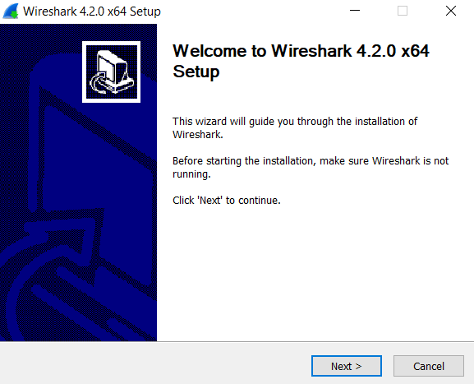

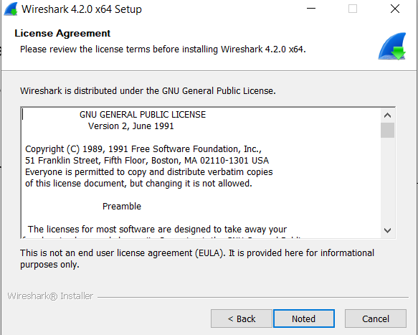
3-Accept the license agreement.

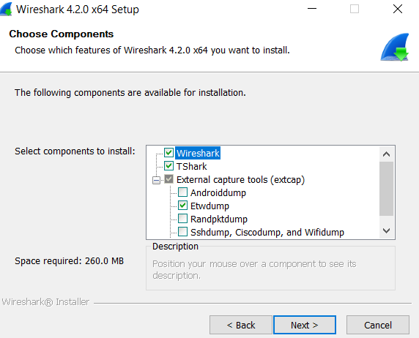

4-Proceed through the steps, leave the default selections
during the rest of the installation.

5-Npcap will install with Wireshark.
Leave the default selections during the rest of the installation.
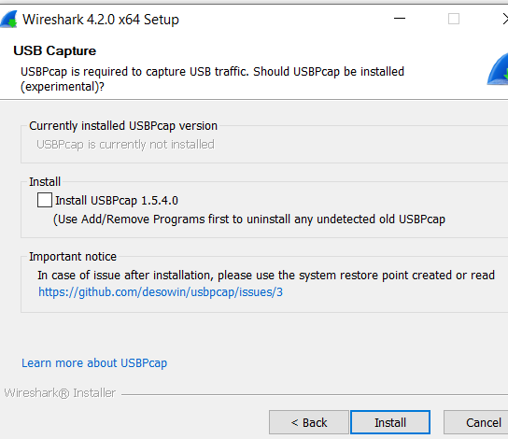

The installation takes a few minutes.
6-If you are asked to reboot when the installation is complete, do so.
Packet Tracer Training
Introduction video to Packet Tracer (note: interface slightly changed). (9 minutes)
https://link.brightcove.com/services/player/bcpid2649990253001?bckey=AQ~~,AAACaPvlvkE~,zCw2Hw90_KSOCz6LjW5G7qKEj3mIN-3H&bctid=4401112045001&secureConnections=true&secureHTMLConnections=true&autoStart=false
[OPTIONAL]: Wireshark Training
Video demonstrating Wireshark's capabilities. Some of the technical terms mentioned will be covered later in the semester. (20 minutes)
https://www.youtube.com/watch?v=qTaOZrDnMzQ

